Inmoov Robot
Bicep, Shoulder, Torso Construction
Author: Grant Cazinha
Winter 2016
Intelligent Robotics ECE 479
Instructor: Marek A. Perkowski

Preface
This report is meant to be a guide for building the bicep, shoulder, and torso of the Inmoov humanoid robot. This report represents the process taken winter term 2016 by a member of the Inmoov team working within the Intelligent Robotics class (ECE 479) at Portland State University. This process was based in part on the instruction supplied at http://inmoov.fr/ by Gaël LANGEVIN.

Index
3D printing the parts
1.0 3D Printing
1.1 3D Printer selection
1.2 Cura
1.3 STL File List and Printing Times
1.3.1 Bicep
1.3.2 Shoulder
1.3.3 Torso

Tools
2.0 Screws, Bolts and miscellaneous items
2.1 Servos

Assembly
3.0 Servos
3.1 Bicep
3.2 Shoulder
3.3 Torso

Conclusion

References

3D printing the parts
___________________________________

1.0 3D Printing

3D printing is an additive manufacturing process of making three dimensional solid objects from digital files. Additive process object creation occurs by laying down the successive layers of material in the pattern of the digital file, one layer building on the previous until the final forma is achieved.

The first step in 3D printing is making a virtual design using a CAD(computer aided tools) program like Blender[1], SketchUp 3D[2]. Your Cad program of choice will export your final project as a .STL file that will be used by your printing software of choice, Cura for example.

1.1 3D Printer Selection

For this project we used the Ultimaker 2 and the ______________.

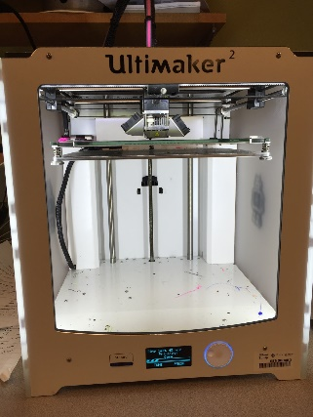
Figure 1.1.1: Ultimaker 2

1.2 Cura

The Cura printing program, developed by Ultimaker, was chosen for this project because it is easy to use and works seamlessly with the Ultimaker discussed earlier. The most current version of Cura can be downloaded free from https://ultimaker.com/en/products/cura-software for educational use.
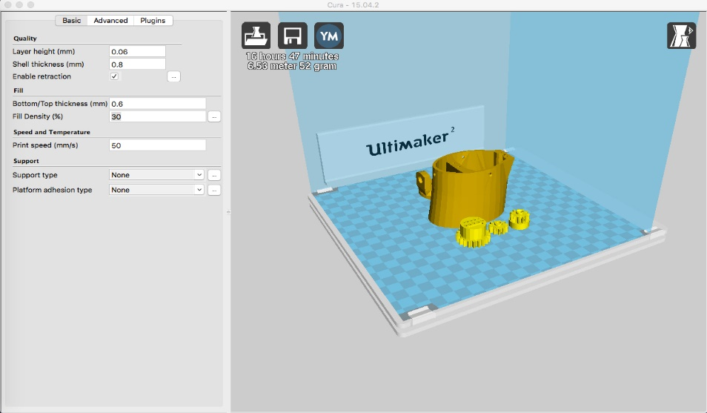
Figure 1.2.1: Cura interface

Steps for starting a print job using Cura:
- Click on “File” and select “Load model file…” from the dropdown list and select the .STL file you wish to print.
- Click “Expert” and select “Switch to full setting…” from the dropdown list. Click “Yes” on the popup window.
- Change the setting on the “Basic” tab to:
Layer Height(mm): 0.08, Shell Thickness(mm): 1.0, Check “Enable Retraction”, Bottom/Top Thickness(mm): 0.4, Fill Density(%): 30, Print Speed(mm/s): 75, Printing Temperature(C): 210, Bed Temperature(C): 75, Diameter(mm): 1.75, Flow(%): 100.0
- After importing your file and setting the print setting you can either export the print job to an SD card by clicking “File” and selecting “Save GCode…” or you can select “Print” to print directly from the computer.
1.3 STL File List and Printing Times (print time in minutes):
1.3.1 Bicep
Bicep
Part | Qty | Print Time
GearHolderV1 | 1 | 25
HighArmsideV2 | 2 | 185
PistonanticlockV2 | 1 | 208
PistonbaseantiV2 | 1 | 129
RotGearV4 | 1 | 215
RotMitV2 | 1 | 229
RotPotentioV2 | 1 | 21
RotTitV2 | 1 | 190
RotWormV5 | 1 | 100
RotCenterV2 | 1 | 376
elbowshaftgearV1 | 1 | 61
gearpotentioV1 | 1 | 17
lowarmsideV1 | 2 | 156
reinforcerV1 | 2 | 67
servobaseV1 | 1 | 133
spacerV1 | 1 | 45
swevoholderV1 | 1 | 197

1.3.2 Shoulder
Shoulder
Part | Qty | Print Time
servoholderV1 | 1 | 190
servoHolsterV1 | 1 | 192
PivTitV1 | 1 | 211
PivWormV2 | 1 | 204
PivCenterV1 | 1 | 440
PivGearV4 | 1 | 225
PivMitV1 | 1 | 263
PivConnectorV1 | 2 | 231
ClaviBackV2 | 1 | 190
ClaviFrontV2 | 1 | 222
PistonbaseV6 | 1 | 203
PistonClaviV3 | 1 | 243
PivPotentioV2 | 1 | 44
PivPotholderV2 | 1 | 210

1.3.3 Torso
Torso
Part | Qty | Print Time
ChestLowV1 | 2 | 89
HomLowBack-V1 | 2 | 253
HomLowFront-V1 | 2 | 250
InterKinectMidV1 | 2 | 143
InterKinectSideV1 | 2 | 215
KinectMidBackV1 | 1 | 288
KinectMidFrontV1 | 1 | 208
KinectSideBackV1 | 2 | 281
KinectSideHolderV1 | 2 | 226
homplateback+V1 | 1 | 251
homplateback-V1 | 1 | 265
homeplatebacklow+V1 | 1 | 256
homeplatebacklow-V1 | 1 | 252
ThroatLowerV1 | 2 | 218
homplatefront+V1 | 1 | 293
homplatefront-V1 | 1 | 283
servoHolsterV1 | 1 | 192
SternumV1 | 1 | 185

Tools
___________________________________

2.0 Screws, Bolts and miscellaneous items

Screws and bolts
This section lists the screws, bolt and other miscellaneous items required for assembly. Screws and bolts can be found at ABS Hardware. Epoxy Glue and grease can be found on Amazon.com.

List of the screws and bolts required

Screw Allen countersunk
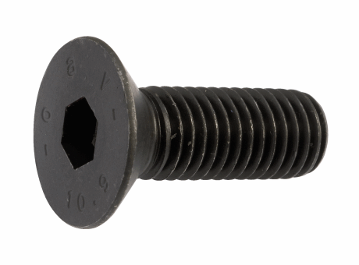
- M3x20MM
- M4x20MM
- M8x100MM
Phillips Flat-Head Wood Screws
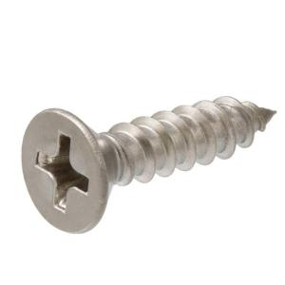
- M3x12MM, about 100 for small servos
- M4x20MM, about 50 for big servos
Miscellaneous items
The list of miscellaneous item required are listed below
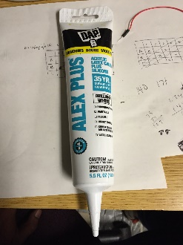
- Alex Plus grease (amazon.com)
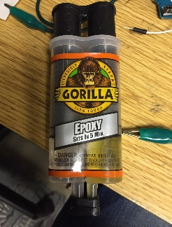
- Gorilla Epoxy(amazon.com)
2.1 Servos

The list of servos required are listed below

5 Hitec HS-805BB servos approximately $50.00 each:

1 for the neck
3 for the shoulder
1 for the bicep

Assembly
___________________________________

There are two things that can be done to make assembly substantially easier. First, print all parts in the highest quality with the greatest infill possible. The most exacting the parts are from the printer, the less you will have to trim and file the parts to fit them together. Printing at higher quality and with more infill will require more time printing, but the tradeoff will be spending less time modifying the parts and fewer parts breaking during assembly. Second, I highly suggest printing all of the parts for a section before starting assembly. Lay out all of the parts for one section at a time; this will familiarize you with all of the parts and how they fit together, and assure you that you have all of the parts. All of the parts for these sections can be fitted together without glue if the parts are cleaned well enough, without removing too much material. I did not use any glue, all parts are tight fitted and could be disassembled if needed, although for some it would be very difficult.

3.0 Servos

Two of the servos in the shoulder and the one in the bicep need to be modified. The potentiometer for each servo needs to be removed from the case so additional lengths of wire can be added. The following instructions will help you perform this set.
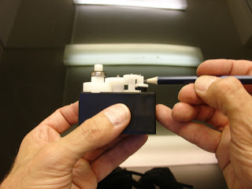
Start by opening the Hitec HS-805BB servo by unscrewing all the screws at the bottom. It comes apart in three sections. Make sure to work in a clean place, you don’t want to lose anything and spoil the grease it contains. Once the top is removed, note or take a picture of each gears placement. You will need to put these gears back exactly as they were originally, and two of them look very similar.
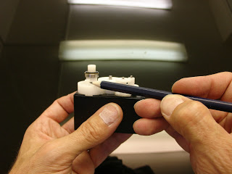
Remove the bearing and it’s rings (note the order). It can be a little hard to remove it.

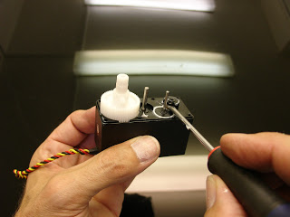
Next you want to remove the pcb and the motor. Push the motor down by pressing the little metal gear placed at the tip of the screw driver in the picture. You might also try using a flathead screwdriver to gently pry the board from the bottom, alternating sides to minimize the possibility of breaking it.

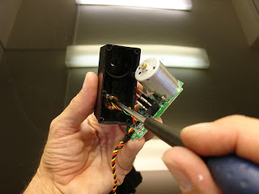
Now that you have access, unscrew the potentiometer from the inside of the housing.

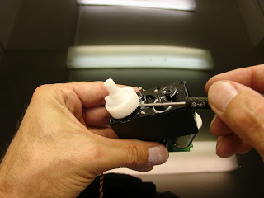
Use a small screwdriver to gently pry up the big gear.

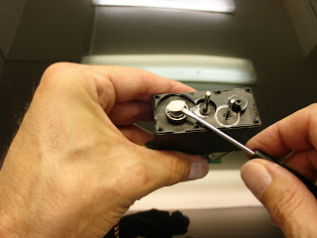
Remove the plastic washer, it is no longer needed and won’t be replaced.

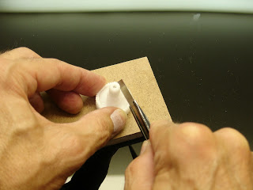
On the large gear there is a plastic edge called the “stopper”. Using an exacto knife, carefully remove the “stopper”. DO NOT CUT YOURSELF AND DO NOT DAMAGE THE GEAR.

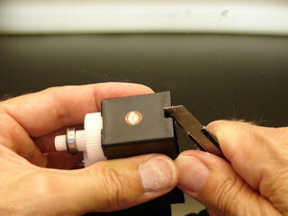
Put all the gears back in their original configuration. Use a cutting utensil to increase the size of the opening in the case for the wires. The added wires for the potentiometer will require more space than the original opening will allow. When unwelding the cables from the board and the potentiometer note the colors.

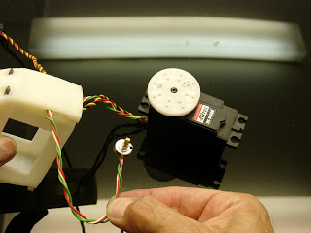
Before welding the potentiometer for the bicep, run your cables through the gap of “servoholderV1″. For the bicep you should add enough wire to have a total length of 25/30 cm.

Depending if you are building the right or left shoulder, you will need to reweld the cables to the potentiometer slightly differently.

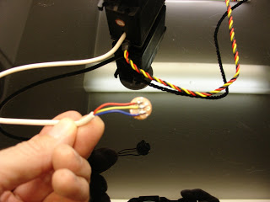
Weld the cables this way, if you are building the right shoulder. In this picture the blue replaces the green or the black wire depending on your servos.

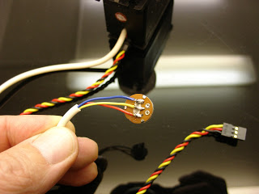
Weld the cables this way, if you are building the left shoulder. In this picture the blue replaces the green or the black wire depending on your servos. This will allow your servo to turn the opposite direction making the initial 0 position the 180 position, and the initial 180 position the 0 position. This should be done the same for both servos for each side

3.1 Bicep

The assembly of the bicep was done by Casimir Sowinski, please see his report for instructions.

3.2 Shoulder

The shoulder consists of two capsule type configurations connected by the two “PivConnectorV1” parts.

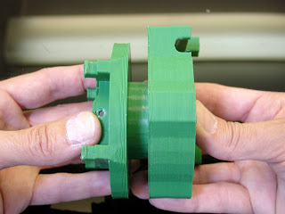
Insert the RotGearV4 into the RotcenterV2 and the into the rotmitV1.

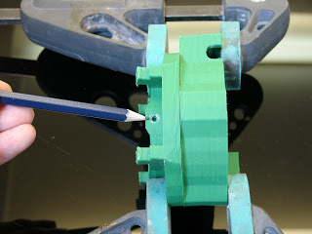
Screw the rotmitV1 to the RotGearV4. Make sure you have the holes lined up well or you will have trouble screwing in the screws. You may need to file out the holes a little to allow the screws to make it through both parts.
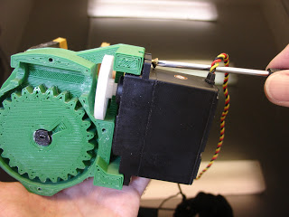
Attach one servo to “rotcenterV1″. At this point only attach the white actuator wheel loosely.
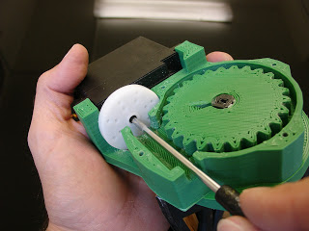
Once the servo is attached, you can tight the screw on the white actuator wheel.
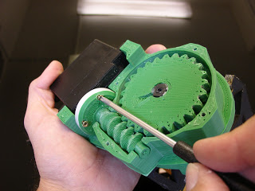
Mount “rotwormV4″ to the actuator with 4 little screws, make sure they don’t come out behind the actuator, otherwise you have to cut them. Mount “rotgearV2″ to “rotcenterV2″, it should turn easily. Before closing the case with “rotTitV1″, use a good amount of grease on all the gears, the more the better.

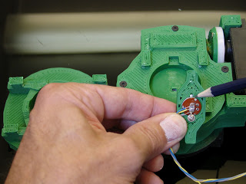
Mount the potentiometer to “rotpotentioV2″ but make sure to place the little metal plate from the potentiometer in the gap designed in “rotpotentioV2″.

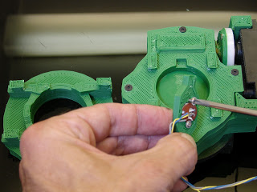
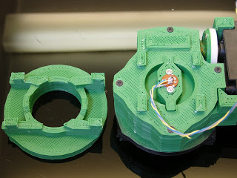
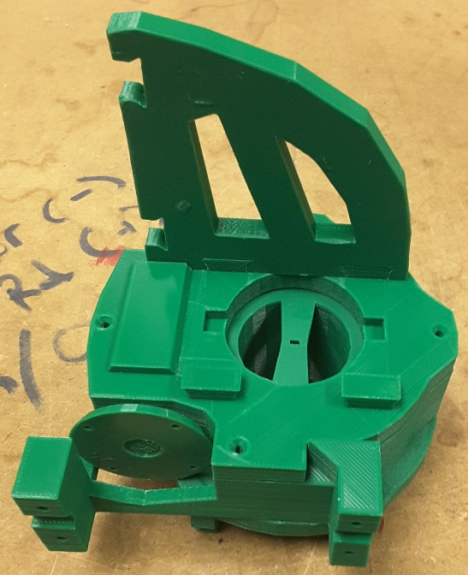
“ConnectorV1” should be connected to both capsules at the same time. Because the two capsules fit together with overlapping parts, you will not be able to connect them one at a time. The picture above is an example of the mistake I made. I had to remove the “ConnectorV1” shortly after this picture was taken, and it wasn’t easy.

3.3 Torso

For the torso I found it easiest if I worked from inside out, assembling the center parts first and working toward the extremities.

I decided to assemble the front of the torso and the back of the torso separately in large planes and the assemble them with the central supports once they were complete.

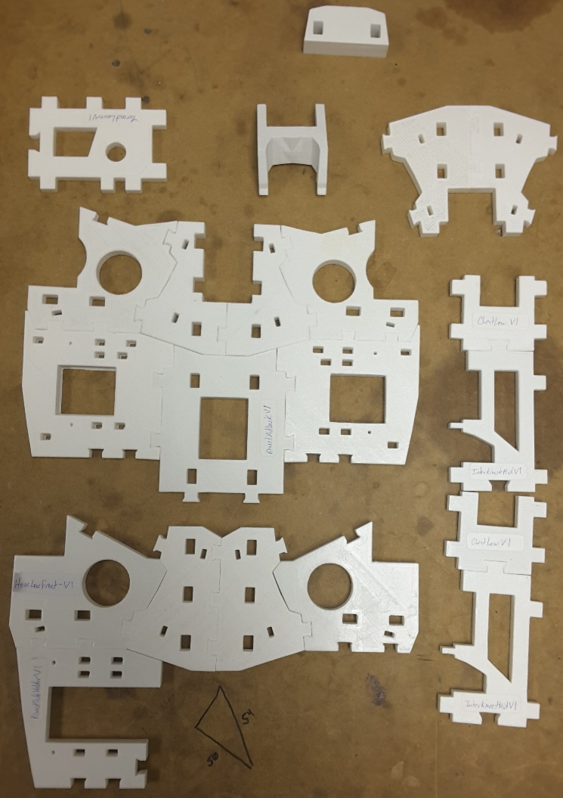
This picture shows the front, back and central portions of the torso in mid assembly. There is only one configuration for the parts, so it is very easy to know how they go together. This is where I repeat that having all of the parts before you start assembly makes knowing what to put together next easier.

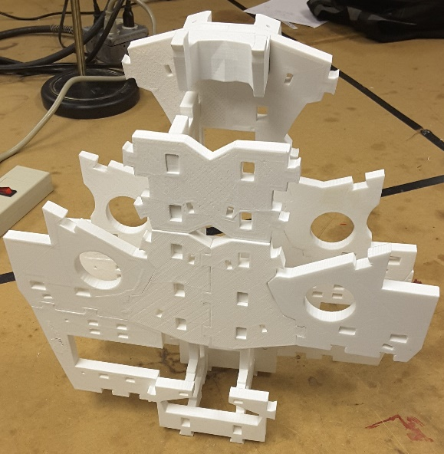
This picture shows a test fit of the front, back and center pieces during assembly. I did many test fits of these three sections to make sure everything was lining up correctly.

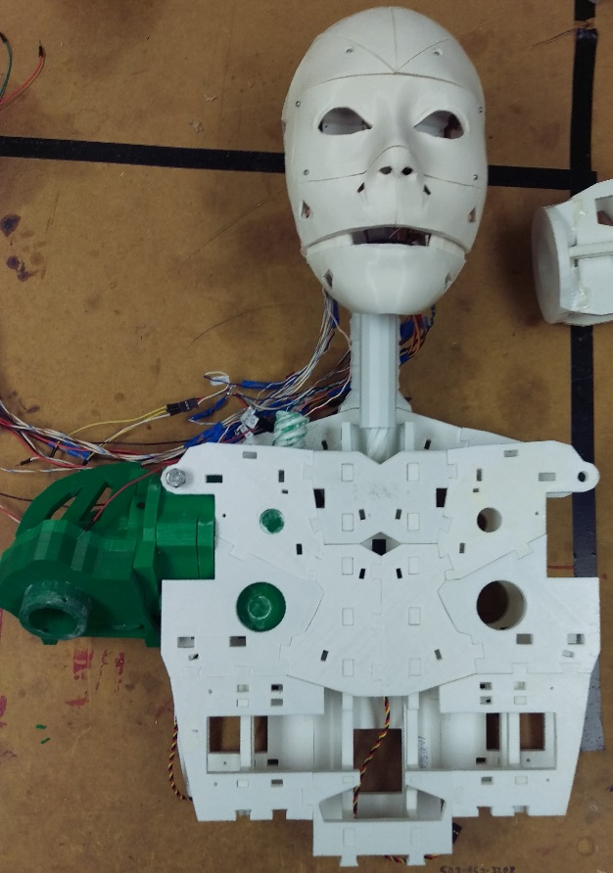

This picture shows the torso completed with the shoulder and head/neck added. The head/neck were assembled in the previous term by other team members.

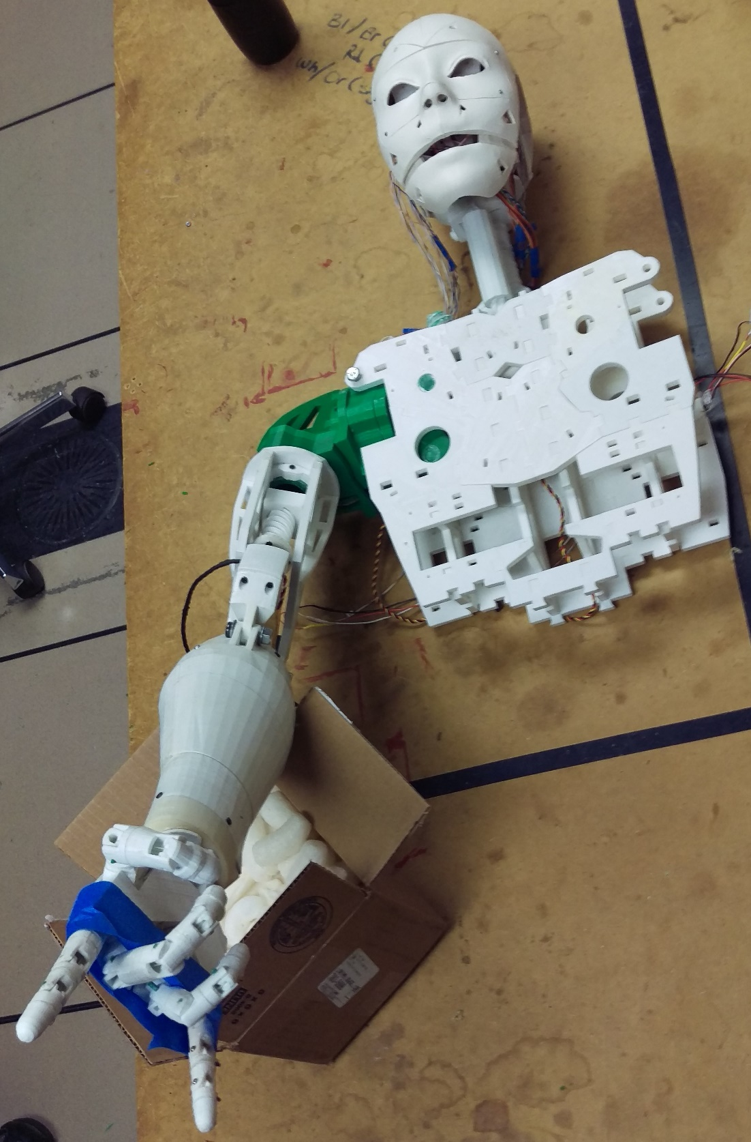
This picture shows the complete torso, shoulder, bicep, forearm, and hand attached. The forearm and hand were completed in the previous term.

Conclusion
___________________________________

The most important observation made during the construction of these Inmoov parts was to start printing early and print with the best quality possible. You will save a lot of time if your parts are clean and sharp when they come off the printer. It is also important to note that the parts were designed to fit together tightly and should not require glue if they are of decent quality and if you take time not to remove too much material when fitting them together. Moving parts, like the shoulder capsules and gears require grease. Don’t be afraid to add a lot of grease, the excess will smoosh out the seams and you can clean it up with a paper towel. It’s better to put more now than to have to add more later.

References
___________________________________

http://inmoov.fr
http://3dprinting.com/what-is-3d-printing/
http://wiki.ultimaker.com/Cura
https://ultimaker.com/en/support/16582-preparing-a-print-file
http://inmoov.fr/default-hardware-map/
https://en.wikipedia.org/wiki/SketchUp
https://en.wikipedia.org/wiki/Blender_(software)
https://en.wikipedia.org/wiki/STL_(file_format)
http://www.digitaltrends.com/cool-tech/abs-vs-pla-3d-printing-materials-comparison/

